Adaptive Web Design

Definition:
# Source: AI Source: Provided by: [Data Path: Persons Table -> ID Column: 1, Name_En Column: Motasem Essam] -> From: [Chatgpt (GPT‑5 Mini)] on [2/12/2026]
Adaptive web design is a type of web design where a website uses multiple fixed layouts that are designed for specific screen sizes or devices. When a user opens the website, it detects the device size and loads the most suitable layout.

Simple Definition
# Source: AI Source: Provided by: [Data Path: Persons Table -> ID Column: 1, Name_En Column: Motasem Essam] -> From: [Chatgpt (GPT‑5 Mini)] on [2/12/2026]
👉 Adaptive web design = a website that switches between predefined layouts based on the device

Key Features
# Source: AI Source: Provided by: [Data Path: Persons Table -> ID Column: 1, Name_En Column: Motasem Essam] -> From: [Chatgpt (GPT‑5 Mini)] on [2/12/2026]
- Uses fixed layouts for different screen sizes
- Detects device type (mobile, tablet, desktop)
- Loads the best matching layout
- Does not continuously resize like responsive design

How It Works
# Source: AI Source: Provided by: [Data Path: Persons Table -> ID Column: 1, Name_En Column: Motasem Essam] -> From: [Chatgpt (GPT‑5 Mini)] on [2/12/2026]
- Desktop → Layout A (e.g., 1200px width)
- Tablet → Layout B (e.g., 768px width)
- Mobile → Layout C (e.g., 375px width)
👉 The website chooses one layout instead of adjusting dynamically

Technologies Used
# Source: AI Source: Provided by: [Data Path: Persons Table -> ID Column: 1, Name_En Column: Motasem Essam] -> From: [Chatgpt (GPT‑5 Mini)] on [2/12/2026]
- HTML
- CSS (with media queries)
- JavaScript (for device detection)
- Sometimes server-side detection

Advantages
# Source: AI Source: Provided by: [Data Path: Persons Table -> ID Column: 1, Name_En Column: Motasem Essam] -> From: [Chatgpt (GPT‑5 Mini)] on [2/12/2026]
- ✅ Optimized layouts for specific devices
- ✅ Faster performance (loads only needed layout)
- ✅ Better control over design for each device
- ✅ Improved user experience for targeted devices

Disadvantages
# Source: AI Source: Provided by: [Data Path: Persons Table -> ID Column: 1, Name_En Column: Motasem Essam] -> From: [Chatgpt (GPT‑5 Mini)] on [2/12/2026]
- ❌ Requires multiple layouts to be designed
- ❌ More time-consuming to develop
- ❌ Not flexible for unknown screen sizes
- ❌ Maintenance is more complex

Use Cases
# Source: AI Source: Provided by: [Data Path: Persons Table -> ID Column: 1, Name_En Column: Motasem Essam] -> From: [Chatgpt (GPT‑5 Mini)] on [2/12/2026]
- Websites with highly customized mobile and desktop experiences
- Large organizations with specific device targeting
- Legacy systems that use predefined breakpoints

Example
# Source: AI Source: Provided by: [Data Path: Persons Table -> ID Column: 1, Name_En Column: Motasem Essam] -> From: [Chatgpt (GPT‑5 Mini)] on [2/12/2026]
- Desktop shows a multi-column layout
- Tablet shows a two-column layout
- Mobile shows a single-column layout
👉 The layout changes in steps, not continuously

Quick Difference (Responsive vs Adaptive)
# Source: AI Source: Provided by: [Data Path: Persons Table -> ID Column: 1, Name_En Column: Motasem Essam] -> From: [Chatgpt (GPT‑5 Mini)] on [2/12/2026]
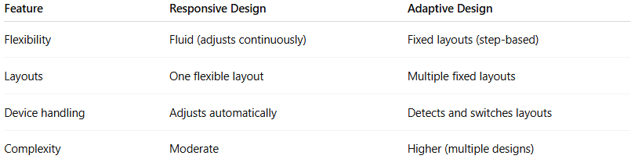
Feature | Responsive Design | Adaptive Design
Flexibility | Fluid (adjusts continuously) | Fixed layouts (step-based)
Layouts | One flexible layout | Multiple fixed layouts
Device handling | Adjusts automatically | Detects and switches layouts
Complexity | Moderate | Higher (multiple designs)

Simple Analogy
# Source: AI Source: Provided by: [Data Path: Persons Table -> ID Column: 1, Name_En Column: Motasem Essam] -> From: [Chatgpt (GPT‑5 Mini)] on [2/12/2026]
Think of adaptive design like different sizes of clothes:
- Small, Medium, Large sizes
- You choose the one that fits best, instead of one size stretching

Summary
# Source: AI Source: Provided by: [Data Path: Persons Table -> ID Column: 1, Name_En Column: Motasem Essam] -> From: [Chatgpt (GPT‑5 Mini)] on [2/12/2026]
👉 Adaptive web design = using predefined layouts for specific screen sizes and switching between them

